**Assignment-3 [ Variables and Exception Handling]**

[Submitted by **Malika Hafiza Pasha**]

1. What will be the output of the following (can/cannot)?
2. Age1=5
3. 5age=55
4. Age_1=100
5. age@1=100

**Answer:**

1. Age1=5 -- Displays output
2. 5age=55 -- Doesn’t display o/p [No such element exists in python that starts with a number, followed by letter]
3. Age_1=100 -- Displays output
4. age@1=100 -- Doesn’t display o/p [No special character exists in python]
5. What are the blocks used in exception handling?
6. Module that deals with Exception handling in Python?

**Answer:**

1. Blocks used in exception handling:
2. TRY BLOCK: it contains set of statements where an exception can occur.
3. CATCH BLOCK: here the expression is handled and the CATCH block must follow the TRY block.
4. If no exception occurs in TRY block, then the CATCH block is completely ignored.
5. Exception Handling in Python

An exception is an error that happens during the execution of a program.

Exception handling is a construct in some programming languages to handle or deal with errors automatically.

1. Value Error
2. Syntax Error
3. Name Error
4. Zero Divisional Error
5. Using Exception handling, write a program to find a reciprocal of the number in a such a way that.
6. If reciprocal exists, it should print reciprocal of that number (take any integer)
7. If reciprocal does not exist, it should print “reciprocal cannot be found” along with the type of error. (take 0).

**Answer:** [Python file is attached with the assignment file]

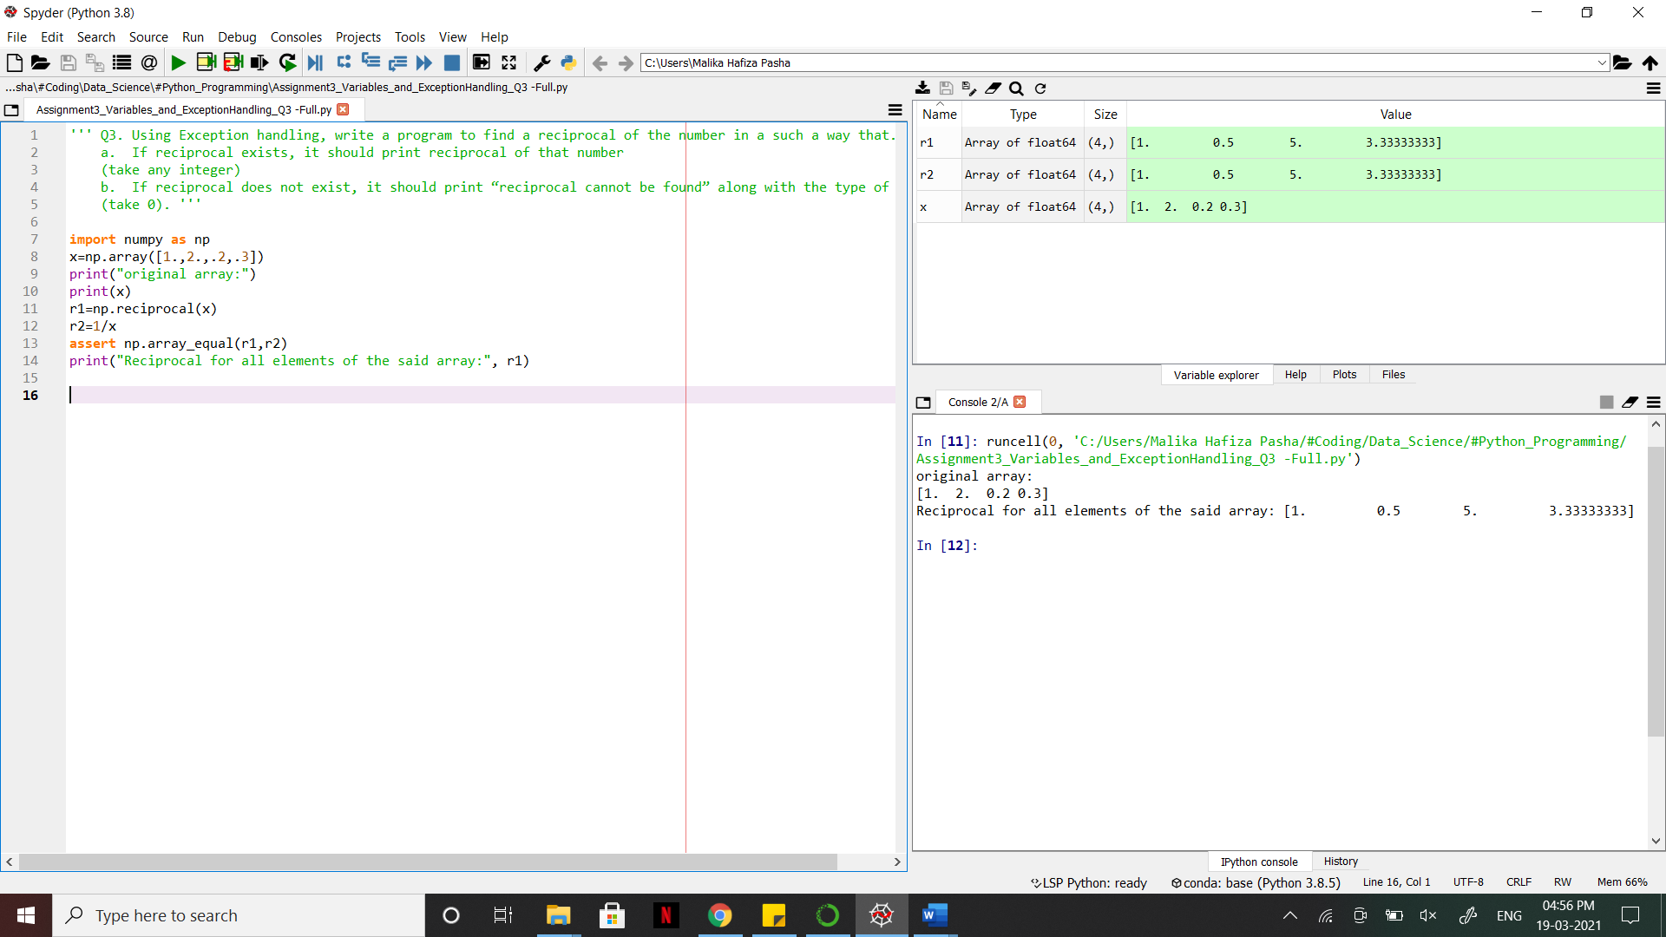

1. How can you delete variables in Python?

**Answer:**

The del keyword is used to delete objects. In Python everything is an object, so the del keyword can also be used to delete variables, lists, or parts of a list etc.